Blocked Order Invoicing Lobby Element– CRIM 0552

|  |  |  |  |  |
| --- | --- | --- | --- | --- |
| **Ver** | **Date** | **Author** | **Comments** | **Reviewed by** |
| 1 | 09/03/2021 | Tom Bell | CRIM 0552 | TBC |
|  |  |  |  |  |

Requirements 2

Prerequisites 2

Solution Overview 2

Solution Details 2

Security 3

Companies 3

Data Migration 3

Test Steps 3

Technical Implementation 3

Requirements

A lobby element in the Credit Manager Lobby that shows the total number blocked Customer Orders on the Handle Blocked Customer Orders screen and a custom RMB to navigate directly to Customer Order.

Solution Overview

A lobby element tile in the Credit Manager Lobby that shows the total number of blocked orders on the Handle Blocked Customer Orders screen.

The lobby element must look like the below screenshot.

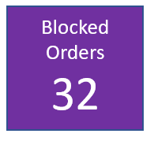

* Lobby Element links to Handle Blocked Customer Orders screen

Solution Details

Lobby Element

The below screenshot shows the Handle Blocked Customer Orders. This is the screen that must be navigated to when the Lobby Element is opened.

The lobby element tile must show the total number of blocked orders on this screen on the front of the tile.

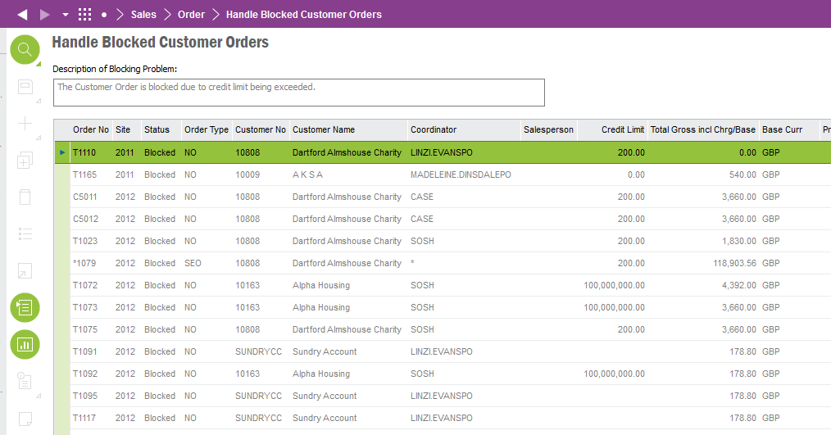

**Technical.**

Field Definitions.

<New Field/CLU Definition>

|  |  |  |  |  |  |  |
| --- | --- | --- | --- | --- | --- | --- |
| New DB Object Name | DB Object Item/Field Names | Item Description | Item Data Type | Item Syntax | Calculation Spec, if Derived | LOVs/Enums/Is Mandatory? |
|  |  |  |  |  |  |  |
|  |  |  |  |  |  |  |
|  |  |  |  |  |  |  |
|  |  |  |  |  |  |  |
|  |  |  |  |  |  |  |
|  |  |  |  |  |  |  |
|  |  |  |  |  |  |  |
|  |  |  |  |  |  |  |
|  |  |  |  |  |  |  |
|  |  |  |  |  |  |  |
|  |  |  |  |  |  |  |
|  |  |  |  |  |  |  |

Security

<Define security controls> (Who needs access to this and will it be restricted from any other users etc)

Companies

Applies to the following companies. All.

|  |  |
| --- | --- |
| **Company** | **Required (Y/N)** |
| 1201 | Y |
| TBC |  |
|  |  |

Data Migration

<Describe any data migration impacts this development may have – i.e additional data to be migrated>

Test Steps

<Steps that needs to be taken to test this change. Please provide expected results> Updated post solution.

|  |  |  |
| --- | --- | --- |
| **No** | **Script\Test Steps** | **Expected Result** |
| 1 |  |  |
| 2 |  |  |
| 3 |  |  |
| 4 |  |  |
|  |  |  |
|  |  |  |

Technical Implementation

1. Element name: C_EA_Blocked_Orders
2. Permission granted: IFS_ALL, FND_QUICK_REPORTS
3. Included in Lobbies:

* Credit Manager
* Accounts Receivable (both Enterprise Explorer and Aurena)